Basic HDL Coding Techniques – Part1 – 20/01/2010 2
Usar blocos dedicados 2
Timing Closure 3
Instanciação versus Inferencia 3
FPGA Resoures 4
Suggested Instantiation 4
Multiplexers: 5
IF- Then 5
Case Statements 6
Other Basic Performance Tips 8
Design síncrono 8
Clock Enables 9
Sync Reset 10
Resumo 10
State Machines 11
Comparação de tipos de codificação de FSM 13
Pipelining 13
Quando usar pipelining 14
Replicate Registers with High-Fanout 16
Pipeline 16
Clock Enable and Gated Clocks 17
Nested If-Then-Else, Case Statements, and Combinatorial For-Loops 17
LUT 17
Componentes especificos 19
Xilinx 19
MUXF5 19
Registrador 21
SRL16 (Spartan 3E) 23
Inicializar Registradores 24
Não utilizar reset “global” 25
CARRY CHAINS 26
COUNTER 26
COMPARAÇÃO 27
Block Memory – Xilinx 29
Opções de sintese e Programação 29
Otimizações para a sintese 30
Opções de síntese 31
Timing Constraints 31
Otimização da FSM 32
Retiming 33
Duplicando registros 33
Resource Sharing 34
Physical Optimization 34
Embedded Blocks 34

Design Hierarquico

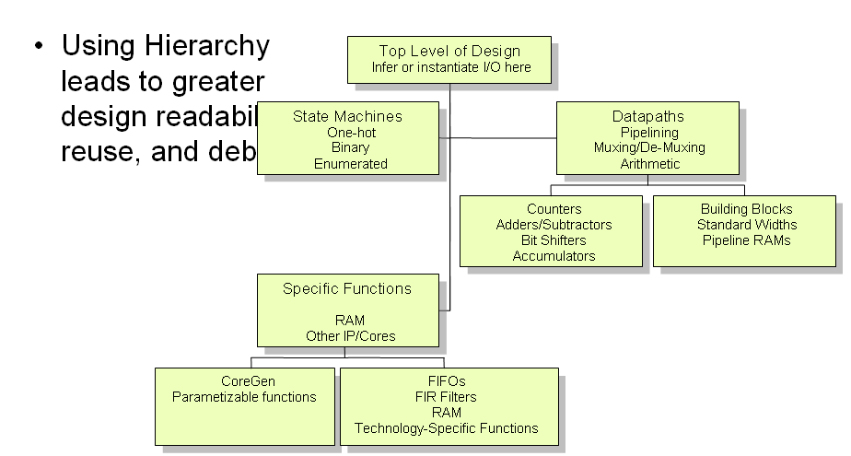

Basic HDL Coding Techniques – Part1 – 20/01/2010

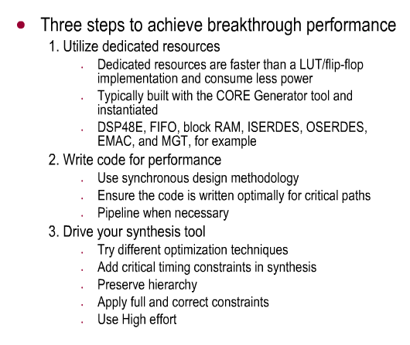

Usar blocos dedicados

- velocidade

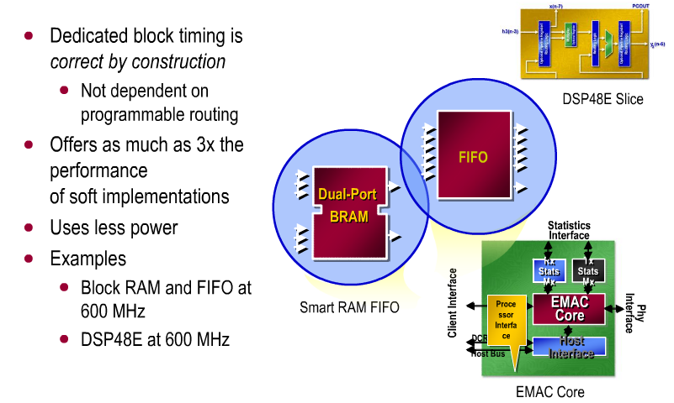

Timing Closure

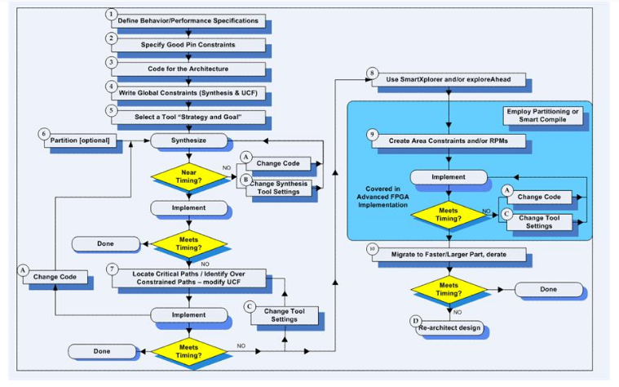

Reduçao do Clock Skew

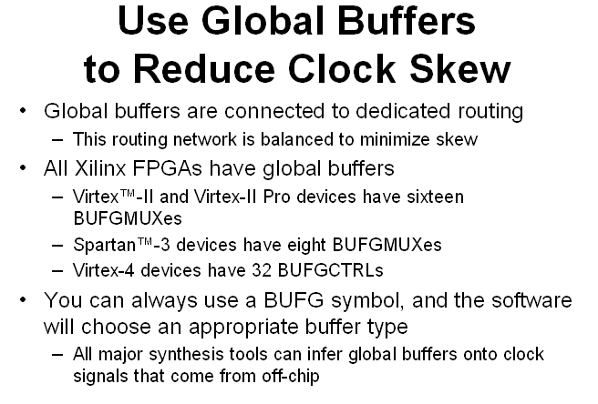

Clock Divider

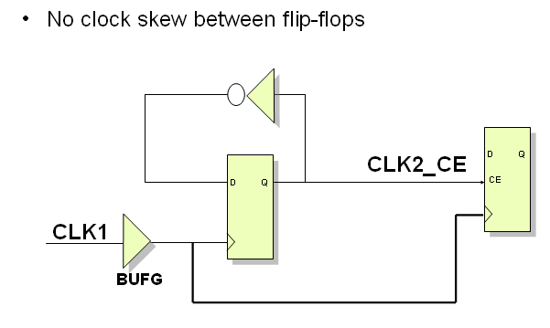

Evitando Clock Glitches
SDT Xilinx
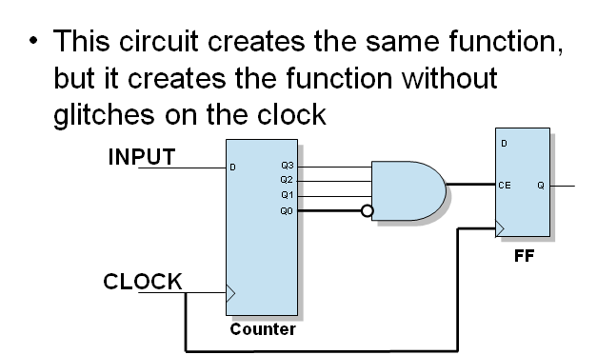

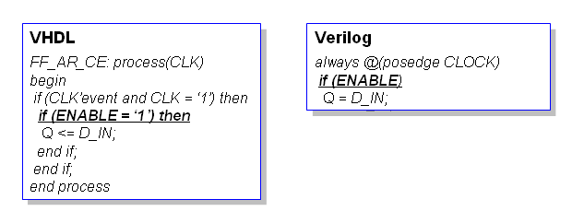

Instanciação versus Inferencia

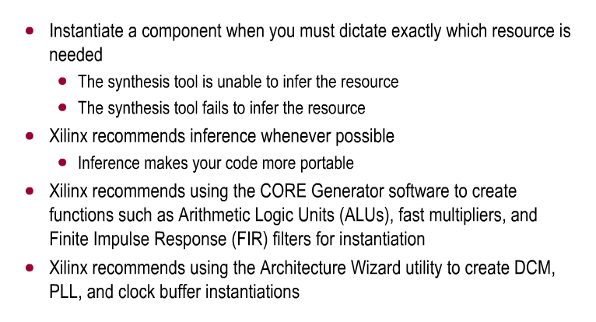

FPGA Resoures

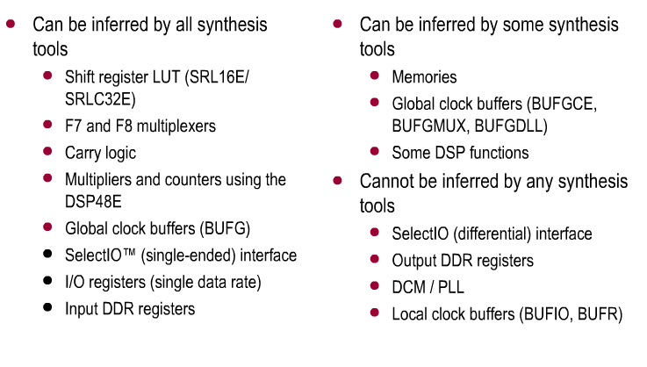

Suggested Instantiation

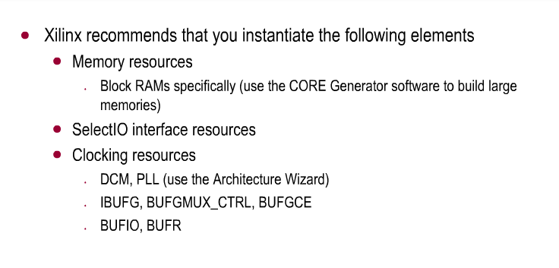

Multiplexers:
Estrutura IF-Then – Codificadores de prioridade, o sinal do ultimo teste será o mais rápido
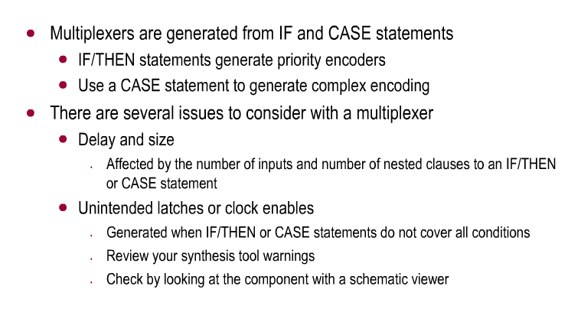

IF- Then

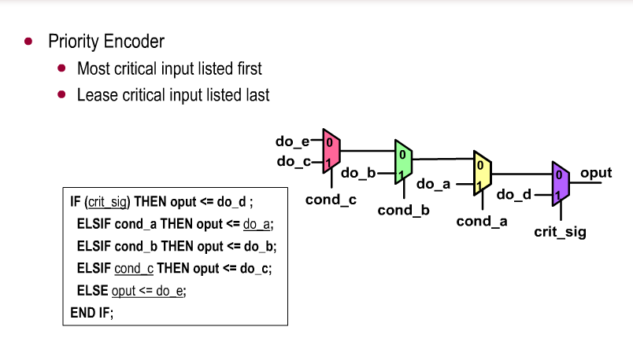
- Evitar cascateamento

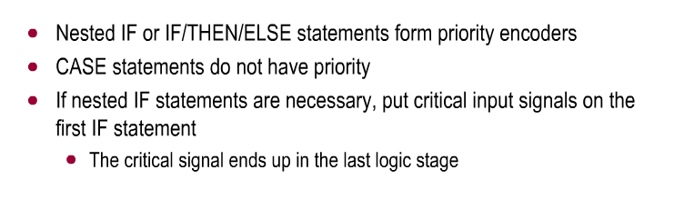

Case Statements

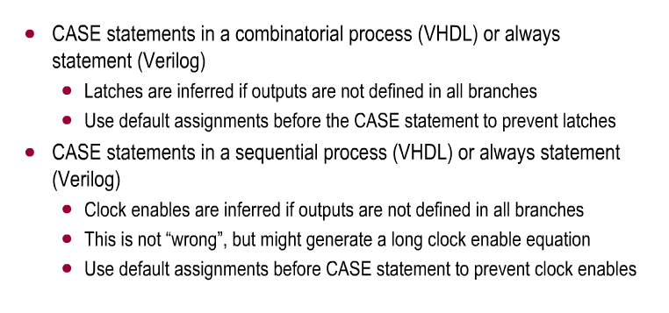

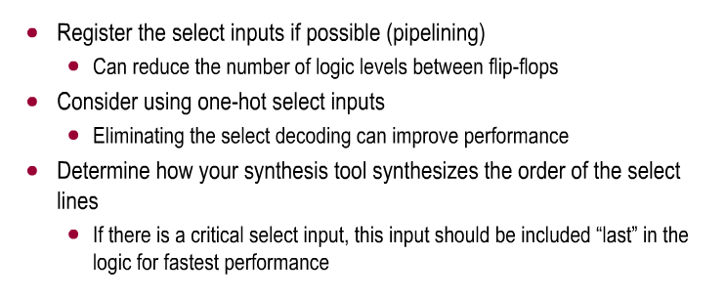

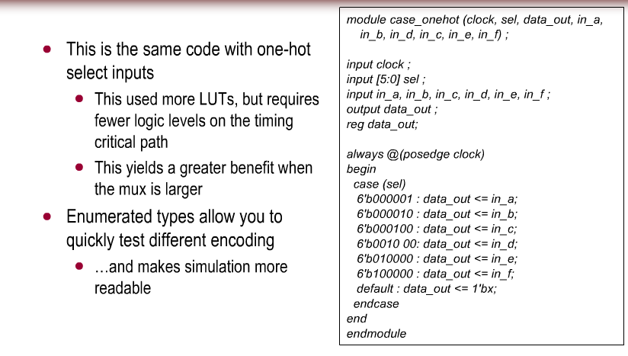

Other Basic Performance Tips

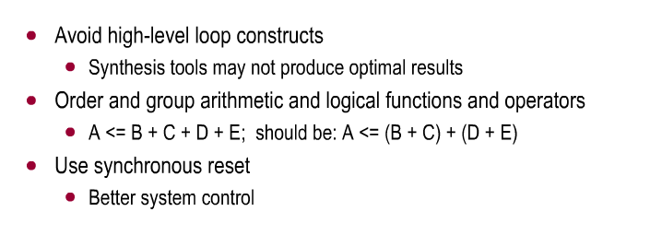

Design síncrono

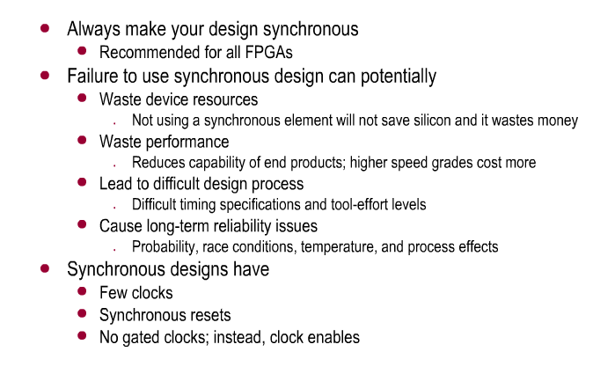

Gated clock pode ocasionar em glitch, utilizar clock enable

Clock Enables

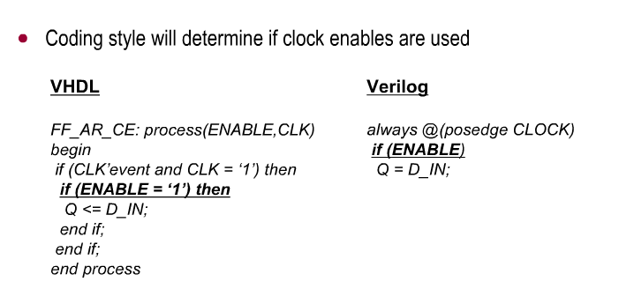
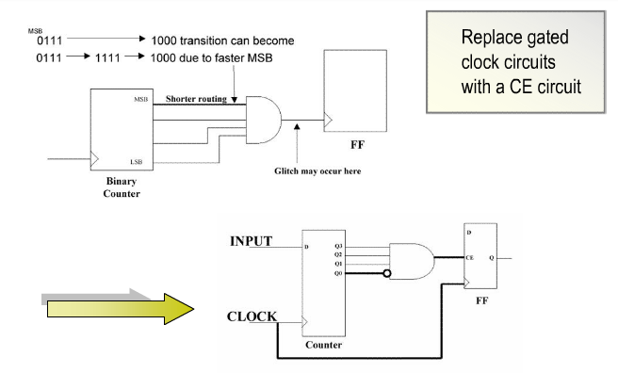
Substituir sinais de pulso resultantes de logica combinacional por um circuito com CE

Sync Reset
Xilinx
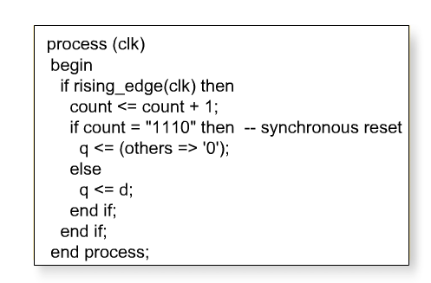

Resumo

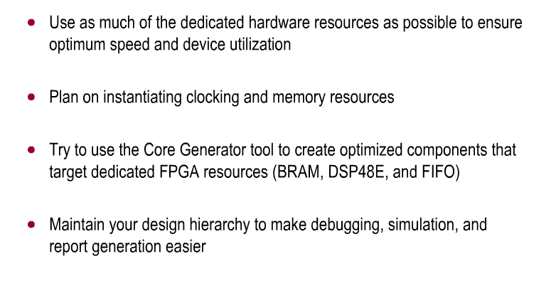
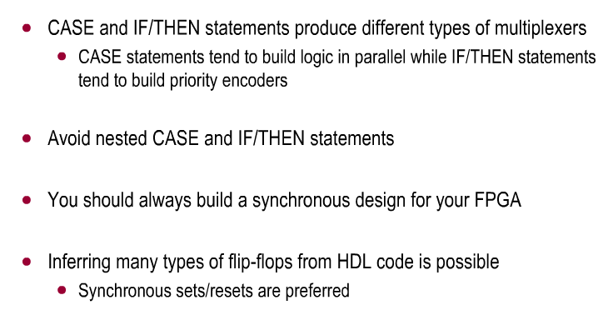
- FFs são elementos muito utilizados, principalmente set/preset sincronos.

State Machines

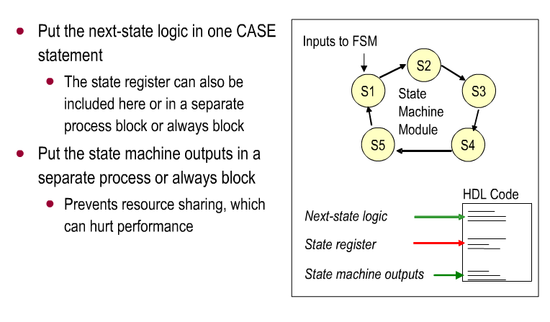
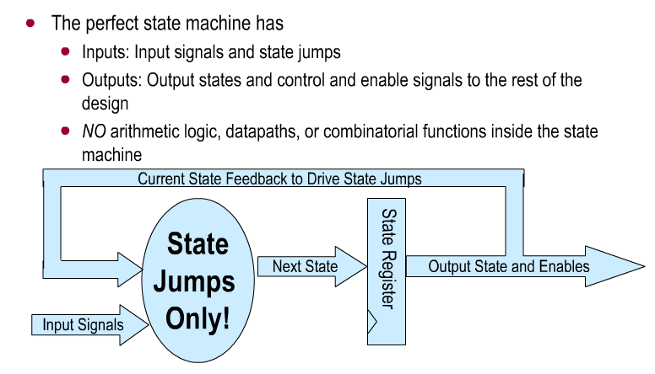
NO.. por que?? menos circuitos lógicos para sintetizar o datapath

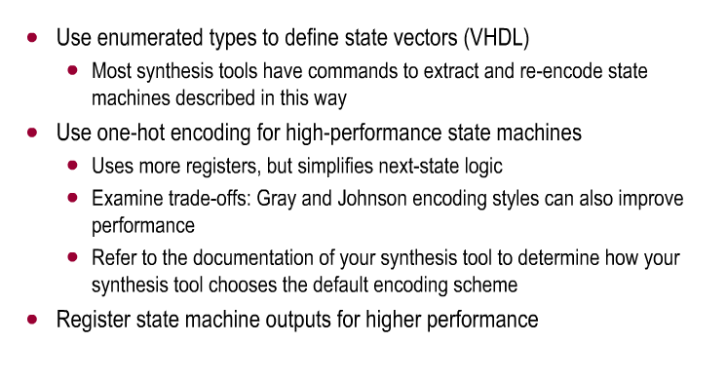

Comparação de tipos de codificação de FSM
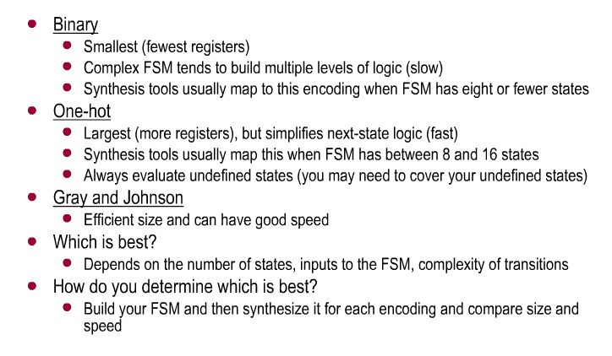

Pipelining

Caveat: atraso no ciclo de relógio conforme se acrescenta registradores

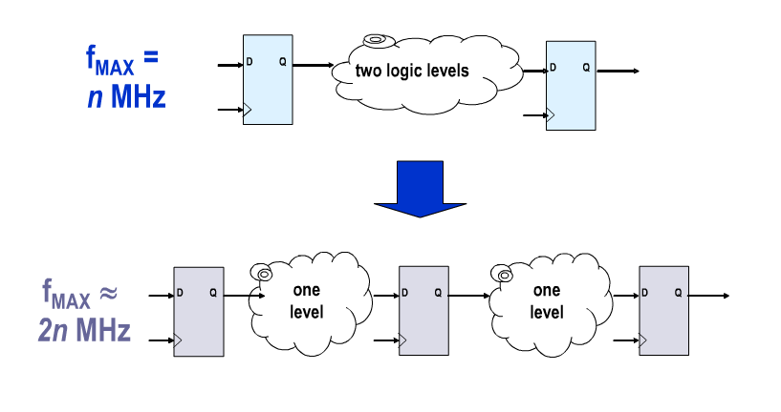

Quando usar pipelining
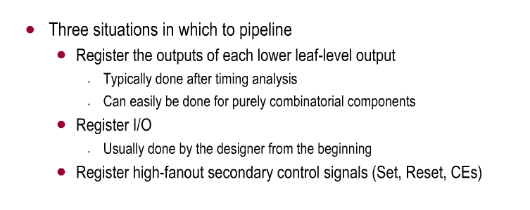

Resumo Parte 2

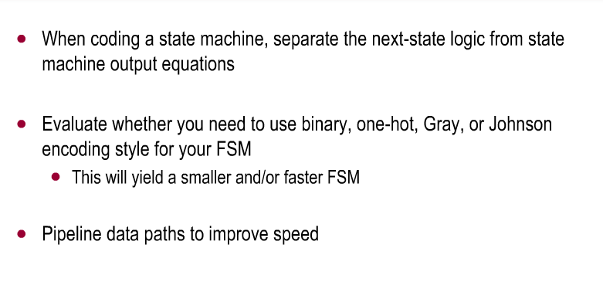

Wp231.pdf

Otimizar a síntese para elementos típicos da arquitetura xilinx.

- Avoid resets on shift registers because it prevents inference of area and
performance optimized SRL library cells.

- Avoid asynchronous reset because it prevents packing of registers into dedicated
resources and affects performance, utilization, and tool optimizations.

- Check whether a global reset is needed.
- Avoid asynchronous control signals.

- IO

All Xilinx FPGAs contain dedicated registers on the FPGA input and output paths. By
utilizing these registers, set-up times for the input paths and clock-to-out times for the
output paths can be minimized, however, their use can lengthen route delays to the internal logic
Como:
1. Disable any global I/O register placement options for the synthesis tool (refer to
synthesis tool documentation).
2. Specify whether the register should be placed into the I/O by adding an
IOB=TRUE in the UCF file or source HDL code (refer to the Constraints Guide for
details on the IOB constraint).
3. Disable the Map option "Pack I/O Registers/Latches into IOBs" in ISE Project
Navigator (or do not use the -pr switch if running from command-line). This
disables automatic pushing of registers into the I/O. See Figure 9.

Replicate Registers with High-Fanout

Register replication is a technique used to increase the speed of critical paths by
making copies of registers to reduce the fan-out of a given signal.

attribute EQUIVALENT_REGISTER_REMOVAL : string;
attribute EQUIVALENT_REGISTER_REMOVAL of
ce1 : signal is "NO";
attribute EQUIVALENT_REGISTER_REMOVAL of
ce2 : signal is "NO";
begin
-- Clock enable register with 64 fanout
-- replicated once
process (clk) begin
if (rising_edge(clk)) then
ce1 <= ce;
ce2 <= ce;
end if;
end process;
process (clk) begin
if (rising_edge(clk)) then
if (ce1='1') then
res(31 downto 0) <= a_data(31 downto 0);
end if;
if (ce2='1') then
res(63 downto 32) <= a_data(63 downto 32);
end if;
end if;
end process;

Pipeline

restructure long datapaths with several
levels of logic and distribute them over multiple clock cycles. This method allows for
a faster clock cycle and increased data throughput at the expense of latency and
pipeline overhead logic management

type regbank6x64 is array(PIPE-1 downto 0) of
std_logic_vector(63 downto 0);
signal prod: regbank6x64;
-- 32x32 multiplier with 4 DSP48 (PIPE=6)
prod(0) <= a * b;
regbank: for i in 1 to PIPE generate begin
process (clk) begin
if (rising_edge(clk)) then
prod(i) <= prod(i-1);
end if;
end process;
end generate;
mult_out <= prod(PIPE)

Clock Enable and Gated Clocks

For CLB registers, Xilinx generally recommends using the dedicated clock-enable port
instead of gating the clock port. Gated clocks can cause glitches, increased clock delay,
clock skew, and other undesirable effects.
To gate entire clock domains
for power reduction, it is preferable to use the clock-enabled global buffer resource
called BUFGCE

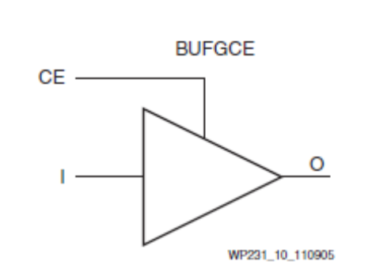

• Avoid gated clocks.
• Use the clock-enable port of global clock buffers to stop the clock on entire clock
domains.
• Use the clock-enable port of registers to locally disable the clock.
• Consider replicating the clock-enable signal if it appears to be part of the paths
that do not meet your timing requirements.

Nested If-Then-Else, Case Statements, and Combinatorial For-Loops

When describing for-loops in HDL, it is preferable to place at least a register in the
datapath especially when there are arithmetic or other logic intensive operations.
During compilation, the synthesis tool unrolls the loop. Without these synchronous
elements, the synthesis tool concatenates the logic created at each iteration of the loop,
potentially resulting in very long combinatorial paths and limiting design
performance.

• Minimize the number of nests within sequential statements.
• Registers should be added to for-loops that are generating long combinatorial
paths.

LUT
http://xilinxc.sabanow.net/xil52prodcontent/rel_downloadable_modules/S3_HDLC_p1/player.html
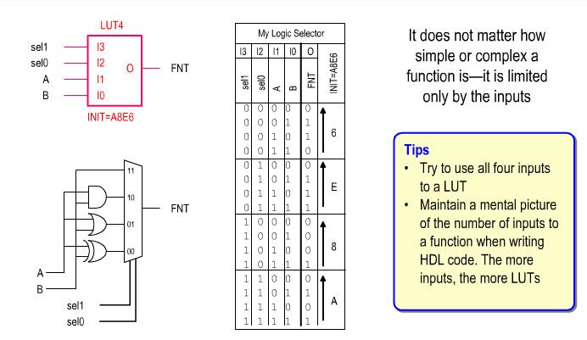

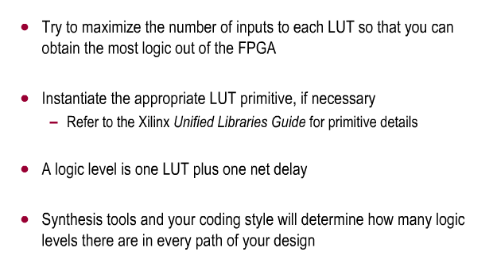

Componentes especificos

Xilinx

MUXF5
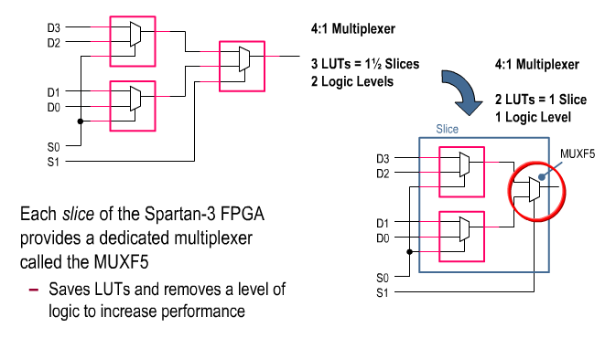

Funções combinacionais com mais de 4 entradas
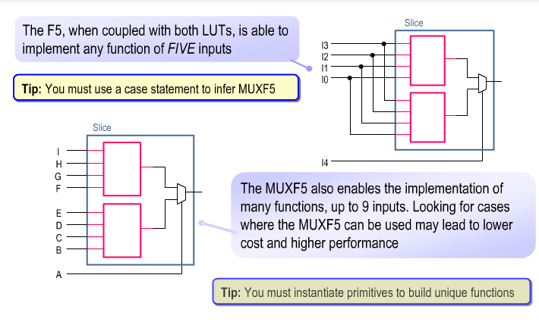
..podendo formar uma tabela verdade de até 32 bits

Mux F5, F6 F7 permitem mais combinações
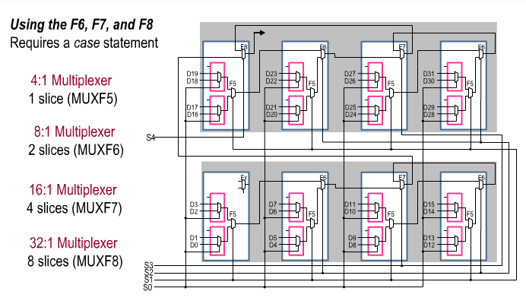
Exemplo
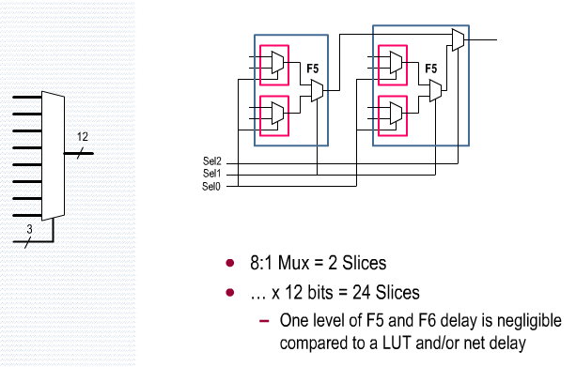
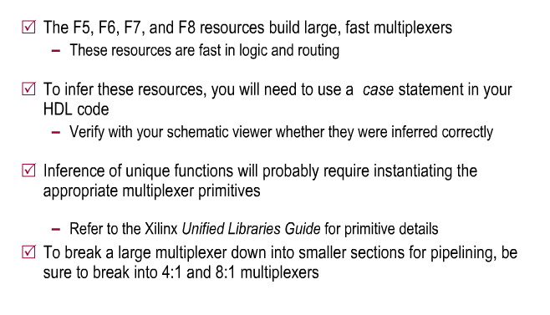

Registrador
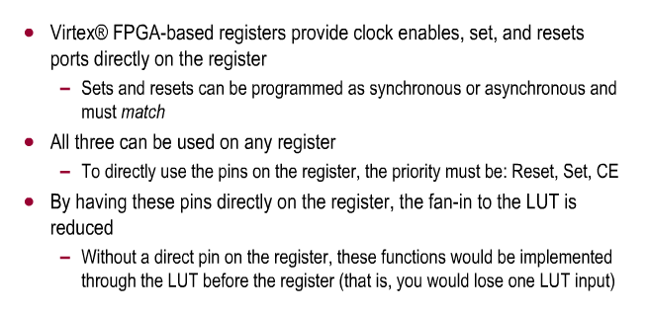
Reset >Set > CE
Pins conectados no registrador

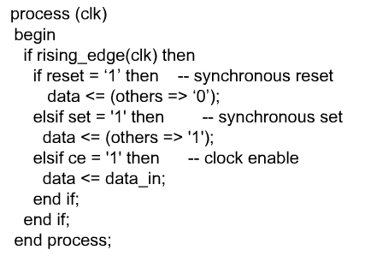

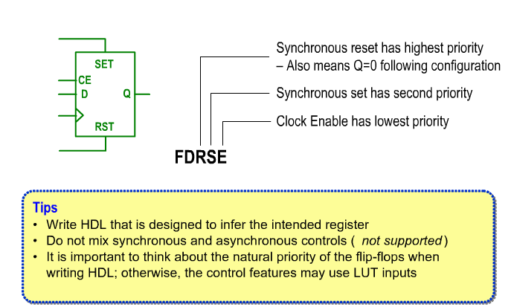
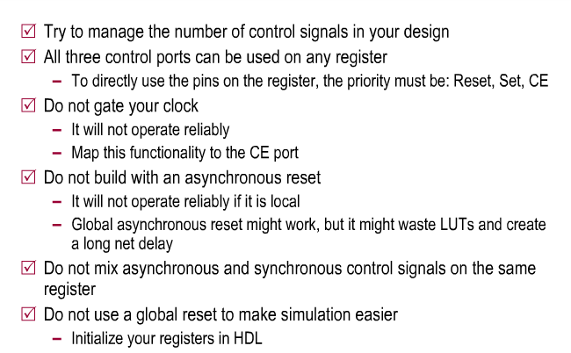

SRL16 (Spartan 3E)
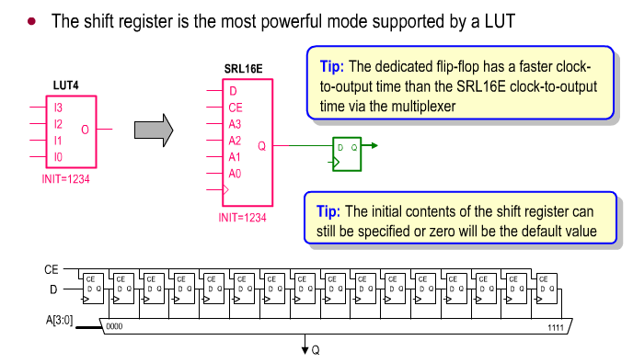
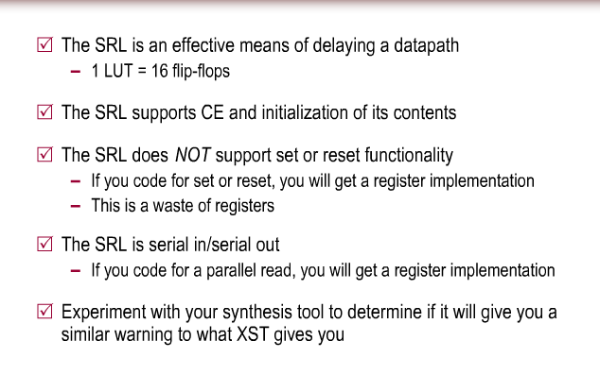

Inicializar Registradores
Pratica utilzada para evitar estados “unknow”
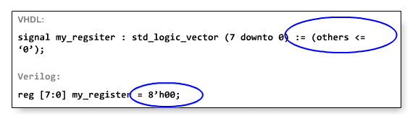

Não utilizar reset “global”
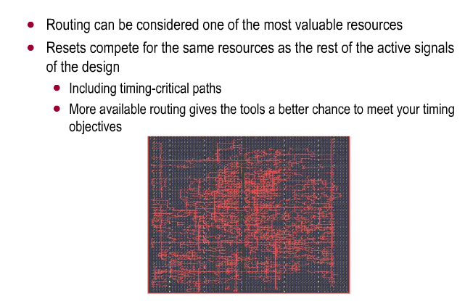
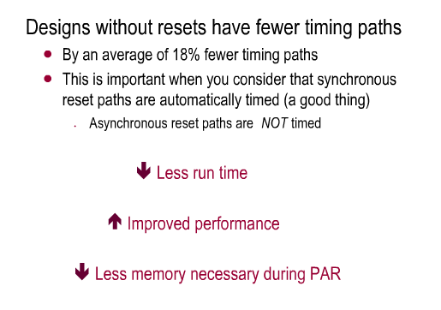

CARRY CHAINS
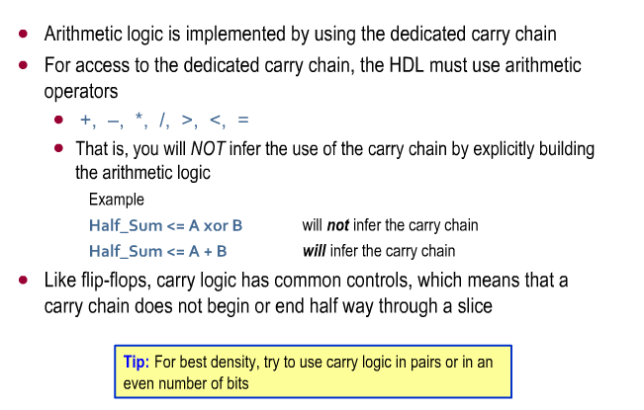

COUNTER
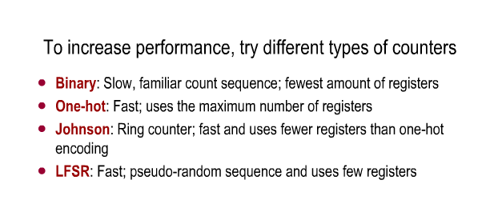

COMPARAÇÃO
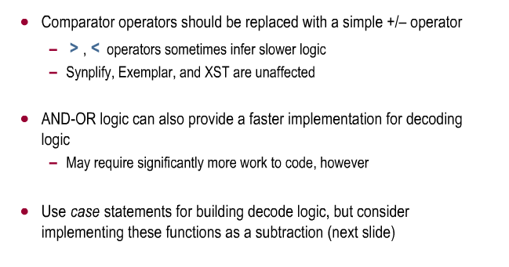
Usar subtração no lugar da comparação, ára utilziar o carry-chain
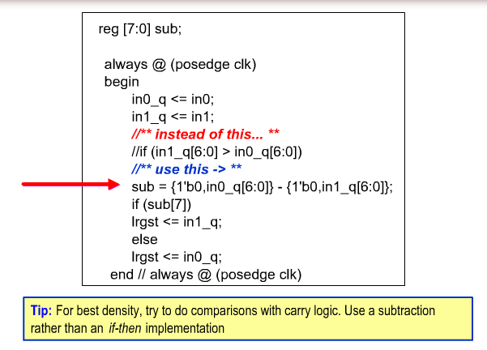
If geran decodificadores de prioridade aninhados…
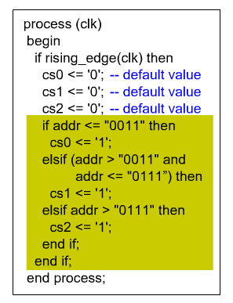
… portanto utilizar case
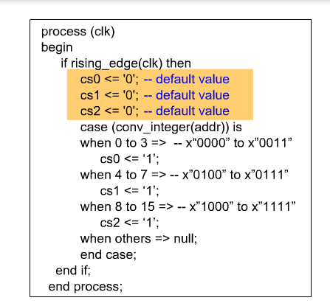
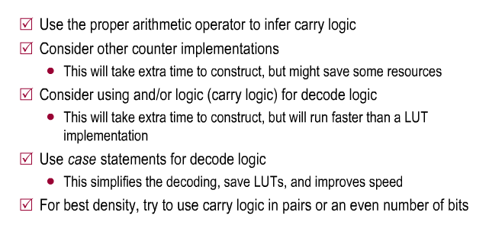

Block Memory – Xilinx
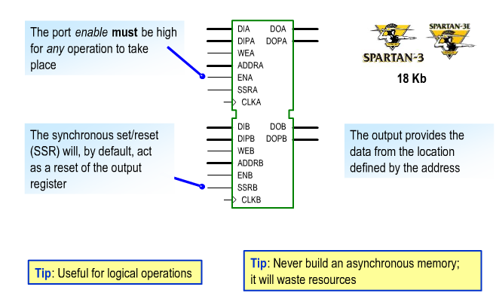

Opções de sintese e Programação
Programar em rtl para ser possivel usar embedded blocks sem modificar muito o design
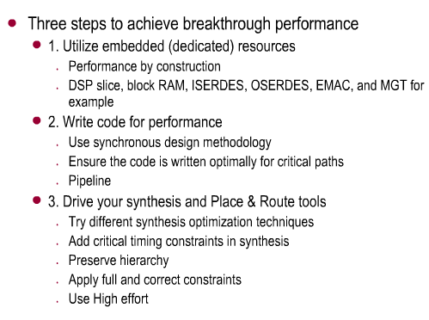

Otimizações para a sintese
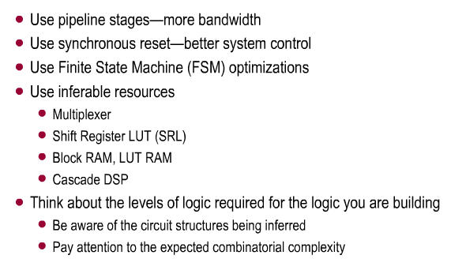

Opções de síntese
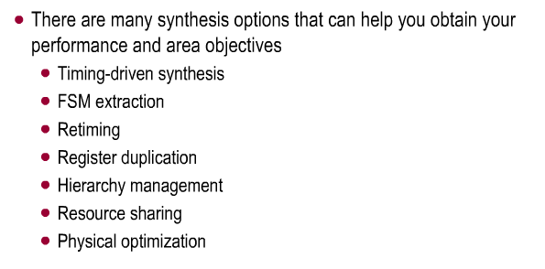

Timing Constraints
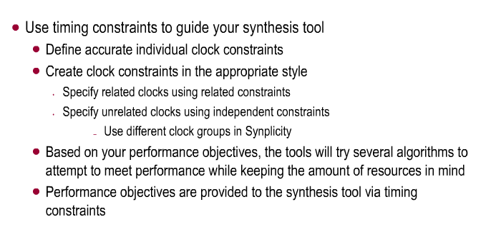
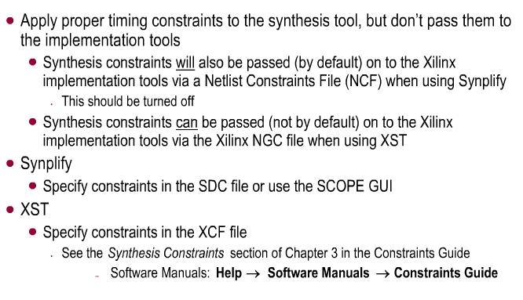

Otimização da FSM
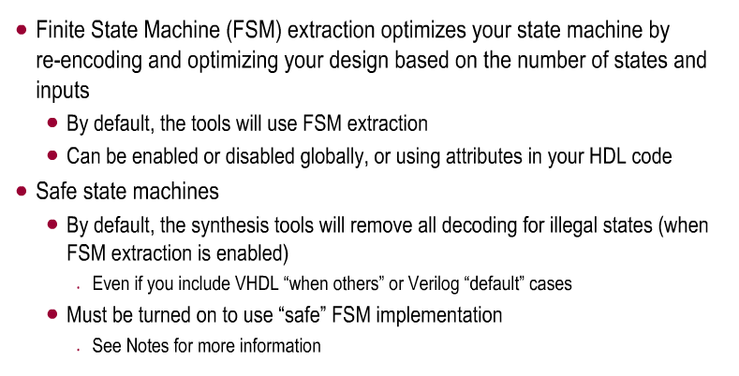

Retiming
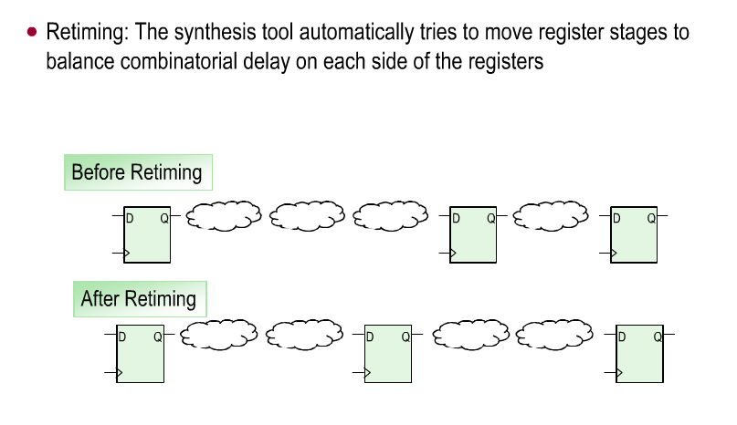

Duplicando registros
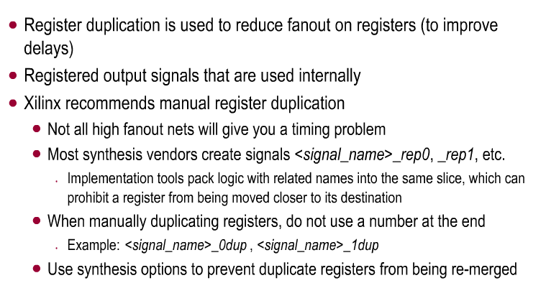

Resource Sharing
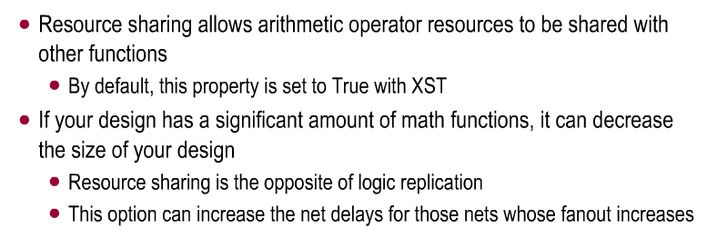

Physical Optimization
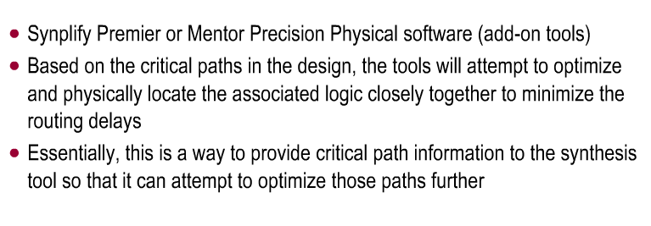

Design Strategy
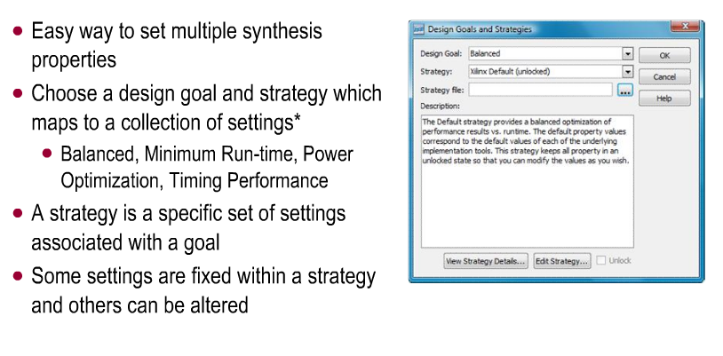

Xilinx XST
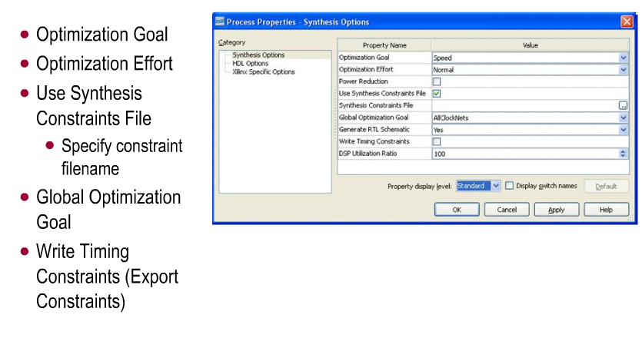

Optimization Goals
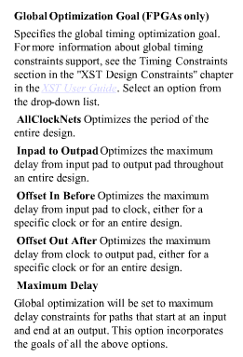

FSM Extraction
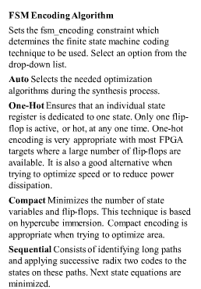
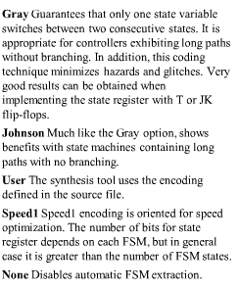

Outras opções
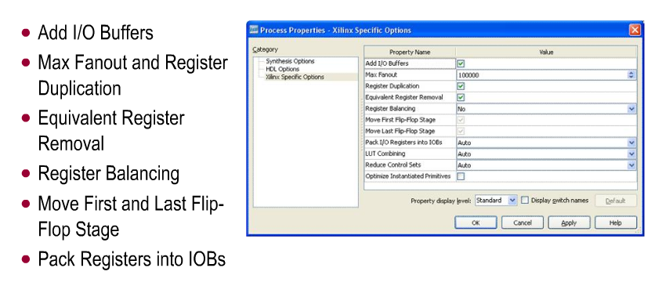

Embedded Blocks
Menor consumo de energia, maior frequencia
